Hospital Readmission Prediction [SDLC]
INTRODUCTION
The Hospital Readmission Prediction System is a web-based application that helps healthcare professionals identify patients who are at risk of being readmitted within 30 days after they’ve been discharged. The goal of the system is to use a synthetic dataset of patient records to support predictive analytics and to assist the professionals in better discharge planning.

PLANNED WORKFLOW
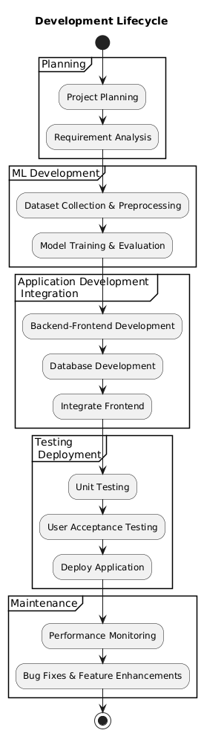
In order to complete the given project in a short span of time (SPRINT Planning), we’ve decided to utilize this workflow in order to quickly finish the product
So, this workflow will be used to show the precise and sequential progress of the development of the application
TECHNOLOGY STACK
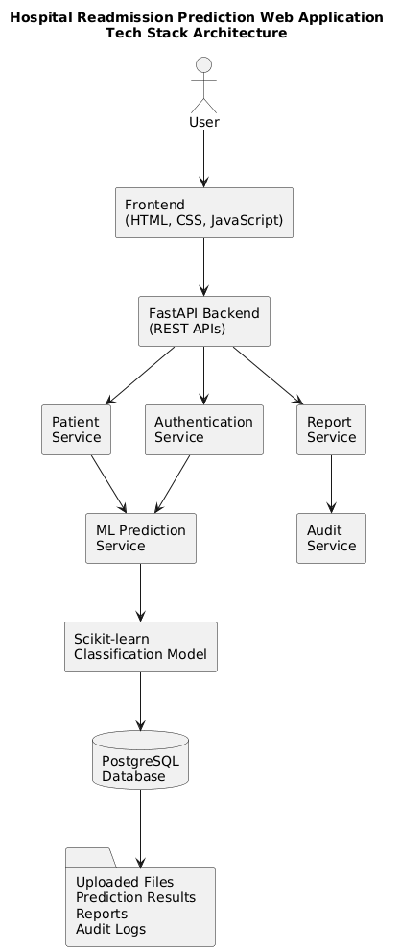
The Tech Stack of this project allows us to build a web-app with a robust foundation for developing a secure, scalable and efficient system which also meets the stakeholder’s requirements
This is done through splitting the core process of the project into Authentication, Prediction, and Reports. Then the tools are used to develop the web-app

TOOLS TO BE USED

Component | Technologies
Frontend | HTML5, CSS3, JavaScript, Bootstrap, Chart.js
Backend | FastAPI
Authentication | JWT, OAuth2
Machine Learning | Scikit-learn, Pandas, NumPy
Database | PostgreSQL
File Handling | Pandas, OpenPyXL
Report Generation | ReportLab, OpenPyXL
Logging | Python Logging, PostgreSQL
Deployment | Docker, Nginx, GitHub Actions, AWS/Azure/Render
By using the above shown tools, the implementation of each component of the technology stack becomes easier, which in turn makes the development cycle of the project easier to follow.

